**Global minimize results**

|  |  |  |  |  |  |  |  |  |  |  |  |  |  |
| --- | --- | --- | --- | --- | --- | --- | --- | --- | --- | --- | --- | --- | --- |
|  | |  | |  |  | |  | |  |  | |  | |
| **Element Amount** | **f_init** | | **f_ph1** | | **it_ph1** | **f_ph2** | | **it_ph2** | | **gNum** | **gNorm** | | **f2_value** | |
| 2 | 21.557 | | 9.83E-05 | | 59 | 0 | | 6 | | 2 | 0 | | 0 | |
| 3 | 272.93 | | 0.012348 | | 38 | 2.73E-12 | | 15 | | 7 | 6.60E-06 | | 1.55E-10 | |
| 4 | 1003.5 | | 0.25211 | | 48 | 7.09E-11 | | 18 | | 8 | 3.42E-05 | | 9.18E-11 | |
| 6 | 286.52 | | 0.74562 | | 51 | 1.35E-10 | | 26 | | 12 | 4.02E-05 | | 1.35E-10 | |

**Legend for the following figures**

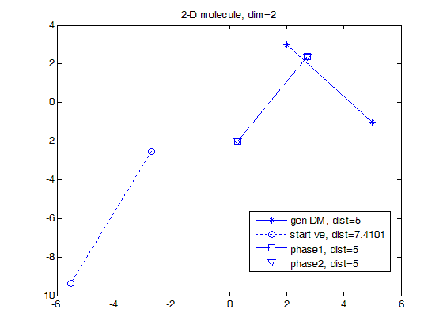

**Figures (next pages)**

